(1) Background:

The NY Community Broadband Partnership (NYCBP), on behalf of Finger Lakes Migrant Health Care Project, Inc. (FLMHCP), is seeking bids for Internet services under the FCC’s Healthcare Connect Fund. The NYCBP is a currently a consortium of healthcare facilities under the FCC Healthcare Connect Fund (HCF) Program representing the FLMHCP, the Finger Lakes Area Counseling & Rehabilitation Agency (FLACRA), ConnextCare Inc. (formerly the Northern Oswego County Health Services, Inc. [NOCHSI]), CASA-Trinity, Inc., Universal Primary Care (UPC), Family Health Network (FHN), and Mosaic Health. It is the vision of the NYCBP to enable a set of standard broadband connection services throughout our facilities (including future members of the NYCBP) that will facilitate any healthcare location in the NYCBP to have health information services with any other healthcare location within our NYCBP and, ultimately, to interconnect with other health care providers regionally and nationally, facilitated over secure, robust and reliable broadband network.
The NYCBP is a non-profit healthcare consortium currently comprised of the facilities of FLMHCP, ConnextCare, FLACRA, CASA-Trinity, UPC, FHN, and Mosaic in New York and Pennsylvania. The NYCBP seeks to grow by adding other healthcare organizations as members. The connectivity provided will continue to build member capacity to health information services and telemedicine services. NYCBP is requesting services for its members that currently do not have adequate telecommunication capacity to handle facility demands.
Since 2008, FLMHCP, the lead agency in the NYCBP, has been the recipient of the USDA Distance Learning and Telemedicine grant and HRSA Network Development grant. Under these grants, they were able to build the Finger Lakes Telehealth Network for distance learning and telemedicine applications. However, the lack of reliable and robust broadband services in the rural communities where our clinics are located has hampered the full utilization of telemedicine and distance learning applications. (See Appendix for Site Locations in Table 1.4)
CASA-Trinity provides high quality, accessible, and effective prevention, education, treatment, referral, and recovery services to individuals, families and communities affected by alcohol, tobacco, and other drugs. The organization began in 1974, serving those in need in Livingston County, NY. In the last ten years, it has expanded its reach and now serves communities in Chemung and Tioga counties as well as communities in Bradford County, Pennsylvania and surrounding areas.
CASA-Trinity is a leader in prevention, recognized as a National Prevention Award for Outcomes winner – as well as a known innovator with its mobile COTI (Center of Treatment Innovations) services and first-of-a-kind residential service at its Wellness Center in Dansville, NY. The organization also has new inpatient and detox services in nearby Hornell and is a certified provider of Medication Assisted Therapy, providing Suboxone, Vivitrol, and Naltrexone treatments in the communities it serves. Focused on quality, evidence-based, comprehensive, and client-centered services, CASA-Trinity has an experienced and credentialed staff of licensed professionals who help clients understand addiction and achieve abstinence-based recovery. The organization operates on a wide array of funding from many different sources including Federal and State grants, State Aid, county funding, school districts, funding from other organizations, and funding from other foundation grants. (See Appendix for Site Locations in Table 1.1)

Family Health Network (FHN) is a Federally Qualified Health Center (FQHC) and a licensed Article 28 Diagnostic and Treatment Center that has been providing primary healthcare to the residents of Central New York since 1972, with a special focus on services to the vulnerable uninsured and underinsured individuals. Organizationally, FHN has (5) freestanding medical centers, one (1) of which includes dental services, plus an additional four (4) school-based health centers in Cortland, Cayuga, and Madison counties; that also service residents of the contiguous counties of Tompkins, Chenango, Broome and Tioga. FHN also provides school-based dental services to eight (8) different school systems for targeted grades.

Family Health Network specializes in providing comprehensive primary healthcare and dental care services directly and by referral. Services offered by FHN include family practice/general practice, dentistry, obstetrics/gynecology, pediatrics, occupational health, behavioral health, substance use disorder, endocrinology, and insurance enrollment. (See Appendix for Site Locations in Table 1.2)

Mosaic Health is a federally qualified health center (FQHC) with operations in the Finger Lakes and Mohawk Valley regions of upstate New York. With five fixed sites, a mobile unit and a portable school-based preventive dental program, Mosaic Health delivers integrated primary care services including medical, integrated behavioral health (psychotherapy and psychiatry), preventive and additional dental services, case management, and care management services to 15,000 patients annually. Having utilized the Rural Area Health Education Consortium for access to USF discounts, Mosaic Health is migrating to the NYCBP consortium due to the greater alignment of mission and vision between the two organizations. (See Appendix for Site Locations in Table 1.3)

(2) RFP Scope:
This RFP seeks to establish new broadband services at 1 CASA-Trinity site that currently has inadequate connectivity for their needs. The services requested will provide connectivity to each site including a secondary connection as specified in Table 1.1 in Appendix.
- PART 1:
  - The Internet connectivity and services, network hardware, and network maintenance for 1 new CASA-Trinity facility currently in the NYCBP that is seeking new or enhanced services listed in Table 1.1.
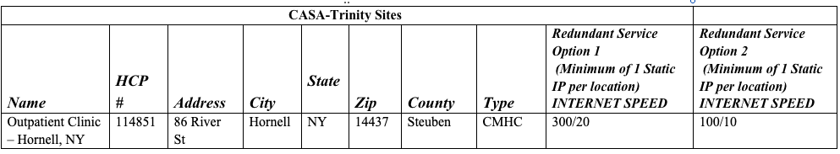

This RFP establishes new or faster Internet connections at 6 Family Health Network (FHN) sites that currently have inadequate connectivity for their needs. The services requested will provide connectivity to each site as specified in Table 1.2.

FHN currently has a point to point Spectrum eLAN between the Health Centers, and the Administration building. All data routes out of the single DIA at the Administration building. The speeds between the eLAN Health Centers vary based on size, but FHN could easily uniform this for ease. FHN is looking at unifying the point to point at the sites at 500 or 1GB, and increasing the DIA to 2GB.

- PART 3: FHN
  - The Internet and/or Ethernet connectivity and service, network hardware, and network maintenance for the 6 FHN facilities that are seeking new or enhanced services listed in Table 1.2.

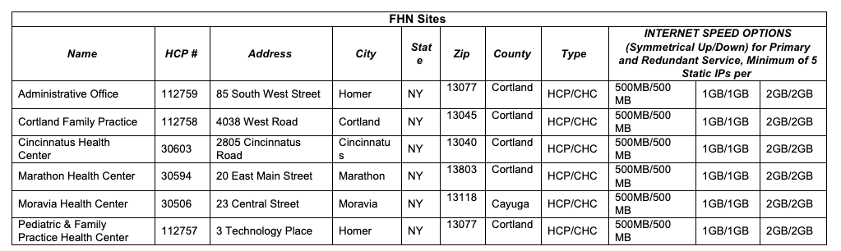

This RFP establishes new or faster Internet connections at 3 Mosaic Health sites that currently have inadequate connectivity for their needs. In addition, we will be looking for redundant services to provide a backup connection to allow continued service in the event of an outage. The services requested will provide connectivity to each site as specified in Table 1.3.

- PART 4: Mosaic Health
  - The Internet connectivity and service, network hardware, and network maintenance for the 3 Mosaic Health facilities that are seeking new or enhanced services listed in Table 1.3.

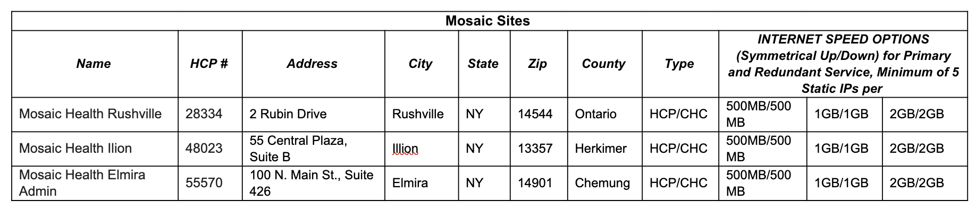
This RFP seeks to establish new and/or redundant broadband services at FLCH sites that currently have inadequate connectivity for their needs. The services requested will provide connectivity to each site as specified in Table 1.4 in Appendix.
- PART 5: FLCH
  - The Internet connectivity and services, network hardware, and network maintenance for existing FLCH facilities currently in the NYCBP that are seeking new or enhanced services listed in Table 1.4.
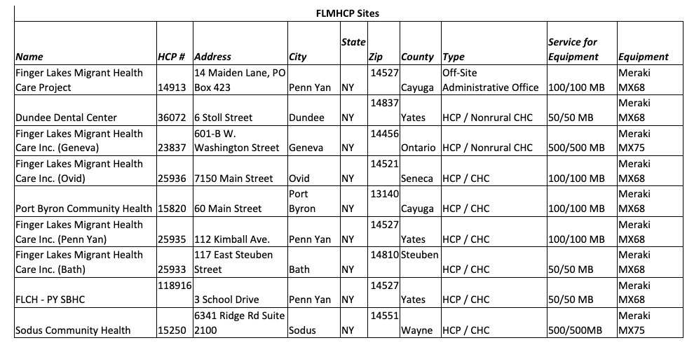

Internet Services:
The configuration must support quality of service (QoS), specifically Differentiated Services Code Point (DSCP) prioritization end to end for telehealth and secure reliable connections for electronic health information exchange. Eventually the connectivity will be able to provide additional services to NYCBP members for a converged IP network that will consolidate many technologies into one platform. The successful bidder(s) will support routes for existing services at the member site to provide a seamless transition to their bandwidth solution(s).

Internet service options for end-user sites should reflect overall pricing, quality standards, and network-wide service requirements as described below and in Table 1.1, 1.2, 1.3, and 1.4. Bids must be responsive to service needs established by end user sites in Table 1.1, 1.2, 1.3, and 1.4. All sites will have Direct Internet Access (DIA) or Ethernet. All site connections are listed in Table 1.1, Table 1.2, Table 1.3, Table 1.4, and the Form 461 attachment, which incorporates this RFP.
Network Hardware:
The hardware for the connections will be purchased and configured through the successful bidder(s) to support these routes. Any ongoing changes to the hardware will be done by the managing entity.

The vendor(s) will be responsible for all network hardware purchasing and maintenance in accordance with the site needs in Table 1.1, 1.2, 1.3, and 1.4. The end user site would be responsible for internal wiring and connection to the room locations where the health information and telehealth equipment will be located. The vendor will be responsible for all network hardware purchasing and maintenance in accordance with the site needs in Table 1.1, 1.2, 1.3, and 1.4 and the parts list included. The vendor shall provide network services in a manner that meets HIPAA requirements concerning telecommunications and Internet services.

Quality of Service (QoS) - All local access circuits and vendor’s core infrastructure network should be designed to deliver QoS, specifically DSCP from end-to-end. Vendor will be required to prioritize traffic with QoS to ensure packet delivery and latency remains at or above industry standards for the routing protocols as well as for switching.

The bidder must describe how they will meet with each location to help set up QoS for each application type.

Network IP services must support: (As a requirement the vendor must be able to guarantee that the requested services are included in the SLA/contract for each connection that will be made. If the parameters cannot be met after the point of implementation, the NYCBP reserves the right to terminate any and all contracts, based on the fact that services are not being met as specified.)
- Specified bandwidth for each site and hardware necessary in Table 1.1, 1.2, 1.3, and 1.4.
- Administrative network security policy and operational requirements for data transport that meets HIPAA security and privacy requirements of State and Federal regulations and statutes.
- Support for standards-based encryption protocols.
- Requirements defined for common technical standards and operational procedures to maintain system reliability, relevant parameters include:
  - An average end to centralized [NYCBP] member hub site delay of less than (<) 20 millisecond.
  - Provide less than (<) 0.1% packet loss.
  - Provide less than (<) 20 millisecond jitter (delay variance).
  - Provide greater than or equal to 99.99% network availability.
  - An average end to Amazon Web Services – Us-East (North Virginia) delay of less than (<) 15 millisecond.
  - An average end to datacenter in Westchester (public IP is 216.105.104.197) delay of less than (<) 20 millisecond.

Proposed system testing and acceptance provisions will be required on all bid proposals. The NYCBP reserves the right to work in concert with vendors to develop appropriate test and acceptance criteria for a specific installation or configuration, to be defined and accepted by both parties prior to contract initiation.

(3) Implementation & Schedule Description:
Any network build-out that is required by the responding bidder, is preferred to occur prior to any inclement weather or winter conditions, and therefore any construction should begin in a mutually-agreed and specified time frame. Please include a plan with timeline, and address ability to meet project timeline goals. Identify circumstances that may create project delays.
(4) Pricing & Cost Information

Vendors submitting proposals should identify all costs associated with the solution they are quoting.
Bidders must provide cost options for (1) owning and (2) leasing the requested infrastructure.

If the services or equipment requested include an ineligible component, bidder to provide pricing for a comparable service or piece of equipment that includes only eligible components.

All hardware MUST BE new and not refurbished equipment.
All equipment in Table 1.1, 1.2, 1.3, and 1.4 and accompanying parts list must be used. The configurations are based on (Manufacturer name) products. Whenever the name of a manufacturer, trade name, brand name, or model and catalog numbers followed by the words "or equal" or "approved equal" are used in the specifications it is for the purpose of item identification and to establish standards of quality, style, and features. Bids on equivalent items of the same quality are invited. However, to receive consideration, such equivalent bids must be accompanied by sufficient descriptive literature and/or specifications to clearly identify the item and provide for competitive evaluation.
Quotes should include the following:
- Implementation fees, including purchase of required new hardware for end-to-end connectivity and initial configuration of network hardware.
- Ongoing transmission fees for end-to-end connectivity.
- Ongoing manufacturer maintenance for the new hardware that will be purchased from (Manufacturer name) 24 x 7 support for 3 years.
- Any other costs associated with the solution that may add cost to participants.

Bid proposals should identify all costs that are included in bid in sufficient detail as to confirm the proposed solution, including installation, configuration, maintenance, and any recurring costs, complies with the Healthcare Connect Fund’s eligibility requirements.
Purchase price for each unit. Bundled pricing may be cited, but individual components must be identified, and detailed pricing provided. Shipping cost for each unit or shipment shall be included as well.
All subcontracting shall be pre-approved by the NYCBP. The Bidder shall be responsible for all subcontractor(s) work and payment. The NYCBP will not pay any subcontractor or third parties directly. Proof of release of liens of subcontractors will need to be submitted prior to invoice approval.
A deadline for bid submissions will be 28 days after the posting of the Form 461 on the USAC web site. Program rules require the Form 461 and RFP to be posted for a minimum of 28 days, meaning that at a minimum a contract could not be signed until the 29th day after posting of the RFP. You must submit one (1) original bound and one (1) electronic copy of your proposal in hard copy format to designated NYCBP Point of Contact.

All bid proposals must understand and acknowledge USAC invoicing requirements and formats. Bidder will conform to invoicing procedures and processes as promulgated by USAC. Any successful bidder(s) is required to have a current Service Provider Identification Number (SPIN) as required by the Healthcare Connect Fund Order. A SPIN number may be obtained by contacting the Universal Services Administrative Company (www.usac.org)

All costs may not qualify for HCF funding. It is critical that accurate, detailed cost information should be provided for all portions of the bid proposal. To obtain funding for the services and equipment being requested through this RFP, the NYCBP is subject to the rules and regulations of the FCC
Healthcare Connect Fund program. Vendors must meet all program requirements. Once the NYCBP has submitted its Form 461 and this RFP, it will be posted to the USAC website. More
information on bidding and posting rules can be found at: https://www.usac.org/rural-health-care/healthcare-connect-fund-program/

(5) Connectivity Requirements
- End-to-end line installation between the facility-designated telecommunications demarcation point in both sites of each site pair is required. Routing and installation particulars are to be determined by the bidder in accordance with the specifications below, and must be described in the bid proposal.
- Dedicated line installation bids are to include all labor and materials needed for the installation of the specified line connectivity, including site survey, engineering, fiber installation, and termination.
- The vendor will obtain permits from departments and/or agencies of cities, state, county, and federal government, railroads, or other entities which provide for the placement of facilities within their respective rights of way.
- The vendor will provide easements for construction on private lands, as needed. Any and all easements must be approved by NYCBP prior to implementation. It is preferred that all easements be one time, advance payments with no recurring charges
- All external fiber installation will be of cable-in-duct construction, using twelve-strand (minimum) single-mode fiber optic cable. Bids for direct-buried cables and/or multi‐mode fiber will not be considered.
- All fiber installation will be installed and tested in accordance with industry-standard practices, including but not limited to the standards promulgated in the National Electrical Safety Code IEEE C.2, NFPA 70, TIA590.A, and TIA.758.A, all as amended. Installation will meet all local building and electrical codes.
- One hundred percent (100%) of all fiber optic media must be tested in accordance with TIA/EIA.568.B.1, TIA/EIA.568.B.3, and TIA.526.7 (single mode). OTDR instrument must be calibrated to show anomalies of .02dB minimum, with photographic or digitized traces provided to the NYCBP site contact.
- Over the life of the contract term, it is likely that locations will need to increase or decrease the bandwidth available for data communications. Vendors must allow for the addition of sites as well as the ability to upgrade or downgrade services at sites as needed throughout the length of the contract term.
- Each location will have the fiber terminated at the Telco demarcation point or the local Information Technology computer room at the discretion of the site coordinator. Site visits will not be permitted at this time. Estimates for onsite facility installation must be a “not to exceed estimate” based on an average internal 1,000 ft cabling path. The final vendor(s) selected will be encouraged to make site visits to finalize their facility cable costs.

(6) Network Management Services for Monitoring and Alerting
Bidders may provide proposals for 24x7 for 365 days network monitoring & alerting.
If the vendor chooses to not quote on the 24 hour network monitoring & alerting, the vendor must allow ICMP (Internet Control Message Protocol) and SNMP (Simple Network Management Protocol) data from the provided router to be provided to NYCBP or a 3rd party for those services.

Each port of the supplied router will be monitored on an agreed upon time interval. Basic performance analytics will be initially provided via SNMP polling. Acceptable, Warning and Loss of Service levels will be established and an alert protocol with escalation will be established. Each location will have a minimum of 2 notification contacts which may be via SMS, email and/or pager. Additional services will be negotiated at a later date to include monitoring of the site firewall device and corresponding ports.

Any additional costs beyond the monthly reoccurring service should be identified in supporting documentation provided with the proposal.

(6) Proposal Requirements
Proposal Format:

Submit one (1) unbound original and one (1) electronic copy (CD, flash drive or other electronic media readily read by Microsoft Office applications) of the proposal. Proposal should be bound, printed on both sides of the paper when possible and organized according to the following outline.

Proposals shall not exceed thirty (30) pages of 8.5x11 size, exclusive of TOC, supporting documentation, schematics, maps, resumes and exhibits.

- Table of Contents: The proposal will have a table of contents with page numbers and pages numbered throughout the proposal.

- Introduction: Brief introduction which includes:
  - The bidder’s legal name and address;
  - Year business was established;
  - Description of the qualifications, experience, capability and/or capacity of the bidder to successfully provide the requested services and complete the project in a timely manner;
  - Contact information for three references from projects similar in size, application and scope. Also provide a brief description of their service;
  - Statement that indicates the proposal is valid for at least 90 days from the proposal submission deadline;
  - Statement that indicates the bidder’s willingness to perform the services described in this RFP;
  - Provide a detailed and precise discussion, including examples and/or documentation, of meeting each requirement of this RFP.
  - A statement that all essential positions and other resources which are required to perform the services described in this RFP will be made available by your organization over the life of the anticipated contract;
  - Completed and signed Representations and Certifications of bidder(attachment);
  - Statement that the signatory has authority to bind the bidder;
  - Signature of authorized individual.

- Firm Profile: Provide a table or chart that shows organizational structure, chain of supervision, decision authority, and communications. Include both the respondent firm and any subcontractor firms

- Project Personnel Qualifications: Professional qualifications and experience of the firm’s proposed Project Manager, other key personnel, and/or team members necessary for satisfactory performance of required services. Include all personnel that will actively be involved with performing the work, to include a listing of all subcontractors, if any, with an explanation of purpose. Individual qualifications are to address the following:
  - Describe your experience working with other projects of similar scale
  - Describe your experience working with healthcare organizations

- Existing Network Facilities in the Project Area: Provide a detailed schematic drawing and map indicating the network facilities owned by the vendor in the region(s) where the project will be implemented

- Proposed Network: Provide a detailed schematic drawing and related maps showing the bidder’s implementation of the proposed network. Clearly indicate the facilities owned by the bidder and the facilities owned by other carriers that will be leased by the bidder to deliver the required services.

- Network Guarantees and Service Level Agreements: Please provide all pertinent network guarantees and service level agreement templates for the network and related services quoted.

- Technical Specifications: Provide all equipment information and technical details supporting the proposed network design.

- Project Costs: Use the partner list to provide the cost for each of the network and service elements provided for each partner. The aggregate network and service costs for each partner should then be totaled. Finally, the aggregate costs for all partners should be totaled to arrive at the overall costs for the project.

- Term: For pricing purposes, please use 3 year and 5 year terms.

(7) Proposal Evaluation:
Any and all costs incurred by Vendor(s) in preparing and submitting a proposal are the Vendor(s) responsibility and shall not be charged to the NYCBP or reflected as an expense of the resulting contracts. Proposed vendor responses will be based on the following:
- Prior Experience, including Past Performance (20 points)
- Network IP Services such as QoS, DSCP and H.323 (20 points)
- Proposed implementation time frames (10 points)
- Solution functions and features and suitability of vendor(s) solution(s) to meet project goals (20 points)
- Cost of solution, both start-up construction and ongoing services (30 points)

The selection will be based on all factors indicated in this section, and may not go to the lowest bidder if cost is outweighed by a combination of other features in the winning vendor’s bid. The point scale listed above will determine the most cost-effective solution for [the NYCBP]’s members.
The NYCBP reserves the right to select bid proposals which, in the sole judgment of the NYCBP, most nearly conforms to the specifications set forth herein.
The NYCBP reserves the right to waive any and all issues of form or presentation in considering bid presentations for acceptance or rejection, if, in the sole opinion of the NYCBP and the NYCBP Leader, such waiver is in the best interests of the project.
The NYCBP is not responsible for any costs incurred by a vendor related to the preparation or delivery of the bid proposal, or any other activities carried out by the vendor as it relates to this RFP.
Questions regarding the RFP can be submitted for the first 14 days from the posting of the RFP. Answers to all questions will be posted on the FLMHCP, NYCBP lead agency, website located at https://localcommunityhealth.com/about-us/ny-community-broadband-partnership/ .
Bidders will be notified within 30 days after the end of the RFP posting period as to which bidder has been selected for a contract award.

All materials submitted in response to the RFP become the property of the NYCBP and proposals and supporting materials will not be returned to bidders.

Bidders are advised that:
    - Pricing will be considered as part of the proposal evaluation process.
    - The award of the contract will not necessarily go to the proposal with the lowest bid.
    - The NYCBP reserves the right to reject any or all proposals

Changes in applicable laws and rules may affect the award process or any resulting contracts. Vendors are responsible for ascertaining pertinent legal requirements and restrictions. Vendors are encouraged to visit the official FCC website pertaining to the Healthcare Connect Fund, at: http://www.fcc.gov/encyclopedia/rural-health-care#HCF
The selection decisions made by NYCBP and reported to USAC under this RFP are final, and appeals or re-submissions will not be considered.
The NYCBP, representing the facilities reserves the right to issue any resulting order with the vendor(s) whose proposal, in the judgment of the group, most nearly conforms to the specifications and will best serve the needs of the [NYCBP] participant members included in this request. [The NYCBP Leader] on behalf the [NYCBP] are not obligated to accept any proposal received. It may accept proposals in whole or in part, or may reject all proposals.

RFP CONTACTS

PRIMARY POINT OF CONTACT

Project Administrative Coordinator:
Rachel Mehlenbacher
NYCBP Project Manager
14 Maiden Lane
Penn Yan, NY 14527
607-329-4826 Cell
315-531-9102
rachelm@flchealth.org

Projector Director:
Mary Zelazny
FLMHCP CEO
14 Maiden Lane
Penn Yan, NY 14527
315-531-9102
maryz@flchealth.org

Appendix - Table 1.1 – CASA-Trinity Site

CASA-Trinity Sites
Name | HCP # | Address | City | State | Zip | County | Type | Redundant Service Option 1  (Minimum of 1 Static IP per location)  INTERNET SPEED | Redundant Service Option 2  (Minimum of 1 Static IP per location)  INTERNET SPEED
Outpatient Clinic – Hornell, NY | 114851 | 86 River St | Hornell | NY | 14437 | Steuben | CMHC | 300/20 | 100/10

Appendix - Table 1.2 – FHN Sites

FHN Sites
Name | HCP # | Address | City | State | Zip | County | Type | INTERNET SPEED OPTIONS (Symmetrical Up/Down) for Primary and Redundant Service, Minimum of 5 Static IPs per
Administrative Office | 112759 | 85 South West Street | Homer | NY | 13077 | Cortland | HCP/CHC | 500MB/500 MB | 1GB/1GB | 2GB/2GB
Cortland Family Practice | 112758 | 4038 West Road | Cortland | NY | 13045 | Cortland | HCP/CHC | 500MB/500 MB | 1GB/1GB | 2GB/2GB
Cincinnatus Health Center | 30603 | 2805 Cincinnatus Road | Cincinnatus | NY | 13040 | Cortland | HCP/CHC | 500MB/500 MB | 1GB/1GB | 2GB/2GB
Marathon Health Center | 30594 | 20 East Main Street | Marathon | NY | 13803 | Cortland | HCP/CHC | 500MB/500 MB | 1GB/1GB | 2GB/2GB
Moravia Health Center | 30506 | 23 Central Street | Moravia | NY | 13118 | Cayuga | HCP/CHC | 500MB/500 MB | 1GB/1GB | 2GB/2GB
Pediatric & Family Practice Health Center | 112757 | 3 Technology Place | Homer | NY | 13077 | Cortland | HCP/CHC | 500MB/500 MB | 1GB/1GB | 2GB/2GB

Appendix - Table 1.3 – Mosaic Sites

Mosaic Sites
Name | HCP # | Address | City | State | Zip | County | Type | INTERNET SPEED OPTIONS (Symmetrical Up/Down) for Primary and Redundant Service, Minimum of 5 Static IPs per
Mosaic Health Rushville | 28334 | 2 Rubin Drive | Rushville | NY | 14544 | Ontario | HCP/CHC | 500MB/500 MB | 1GB/1GB | 2GB/2GB
Mosaic Health Ilion | 48023 | 55 Central Plaza, Suite B | Illion | NY | 13357 | Herkimer | HCP/CHC | 500MB/500 MB | 1GB/1GB | 2GB/2GB
Mosaic Health Elmira Admin | 55570 | 100 N. Main St., Suite 426 | Elmira | NY | 14901 | Chemung | HCP/CHC | 500MB/500 MB | 1GB/1GB | 2GB/2GB

Appendix - Table 1.4 – FLCH Sites

Network Design CASA-Trinity – 2.1
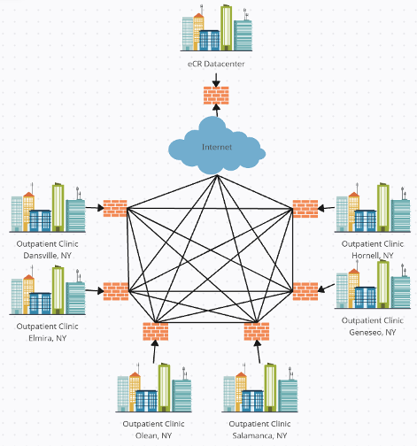

Network Design FHN – 2.2
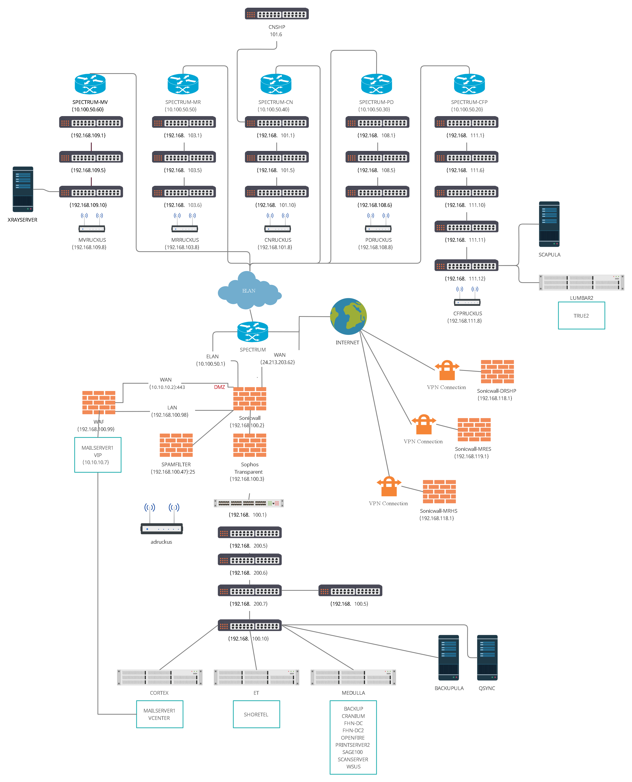

Network Design Mosaic– 2.3
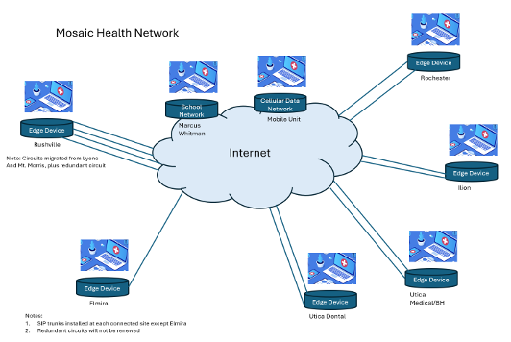

Network Design FLCH– 2.4
